

PROJECT MANAGEMENT | CAD DEPARTMENT

CAD Setup Document

**Project Name:** CAD Setup

**Project Manager Name:** Aimee Olding

**Project Sponsor:** Aimee Olding

**Project Team Member Names:** All CAD Users

**Date:** 07-05-2017

**Prepared by:** Alex Lundin

# Table of Contents

## Purpose

## Reset AutoCAD to default

## Steps

## Lisp Routines

## Network Drive Locations

# Setup

## Purpose

This file will provide step by step instructions to configure AutoCAD software to Wattstopper standards. Every setting necessary to create Wattstopper drawings will be covered. The Setup document is a living manuscript and may be updated as the need arises. These guidelines are subject to change at any time and are ever evolving. Changes to this text will be posted, to the H Drive, as they become available.

## Reset AutoCAD to default

* 1. Click start
  2. Choose all programs
  3. Navigate to AutoDesk folder
  4. Choose your version of AutoCAD
     1. **AutoCAD – 2013 English**
  5. Click Reset Settings to Default

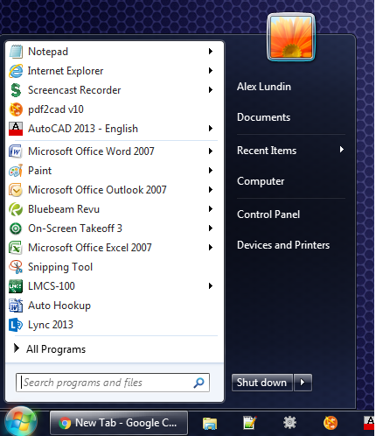

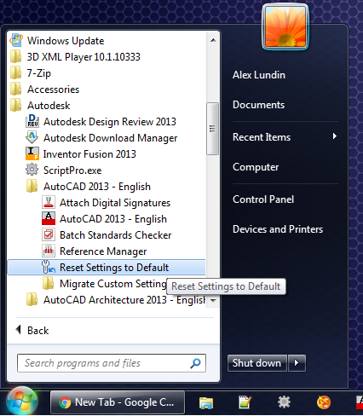

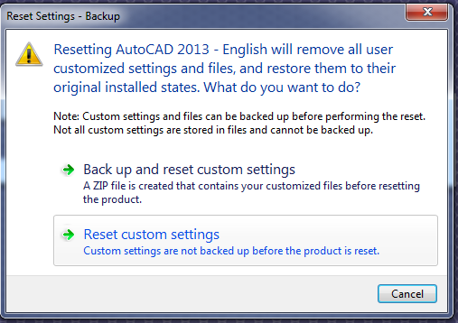

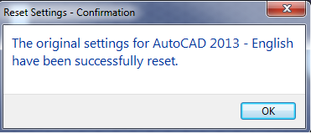

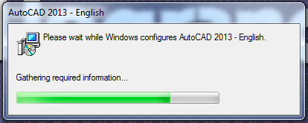

## Steps

* 1. **Copy WS_Blocks folder from H Drive to C Drive**
     1. Type either location below into windows explorer (or cntrl-click)

H:\Drawings

P:\1 AutoCAD Main

* + 1. Copy WS_Blocks
    2. Paste into C:\

**C:\**

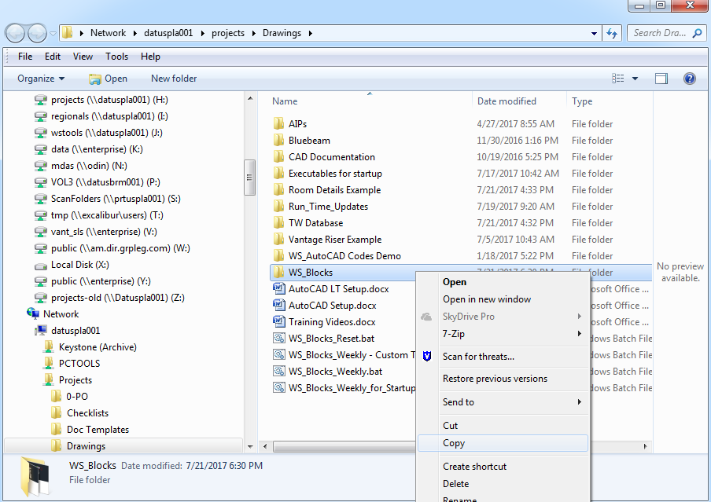

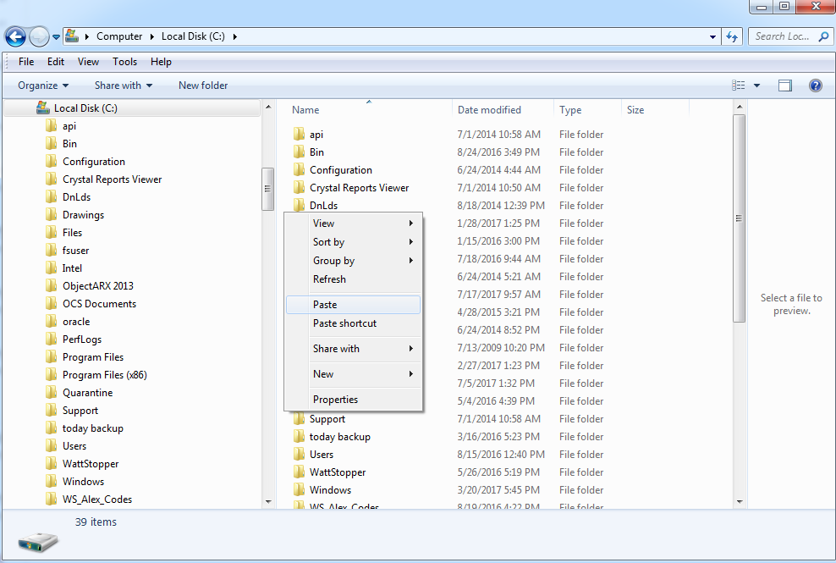

* 1. **Open AutoCAD**
     1. Navigate to Start menu
     2. Click All Programs
     3. Click Autodesk Folder
     4. **Click AutoCAD-20XX-Enlgish**
     5. **\*\* Make sure to choose regular AutoCAD**
        1. **Not architecture or mechanical**

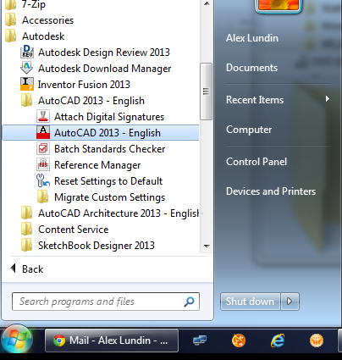

* 1. **Increase Hardware Acceleration**
     1. Type GRAPHICSCONFIG into command line
     2. Check Enable Hardware Acceleration at the top

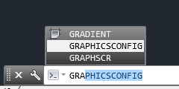

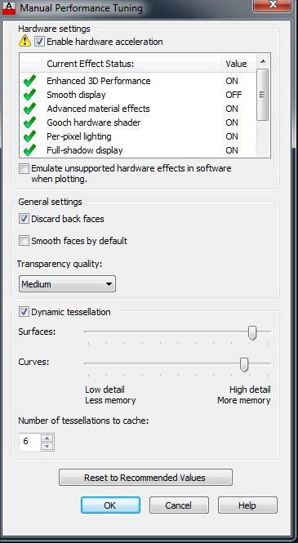

* 1. **Set AutoCAD Options with VLISP**
     1. Type VLISP into the AutoCAD command line
     2. Type Enter



* + 1. The Visual Lisp Console will open up

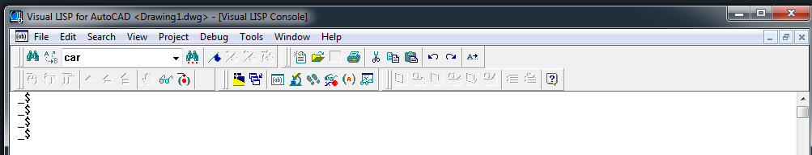

* + 1. Click file open on the left hand side

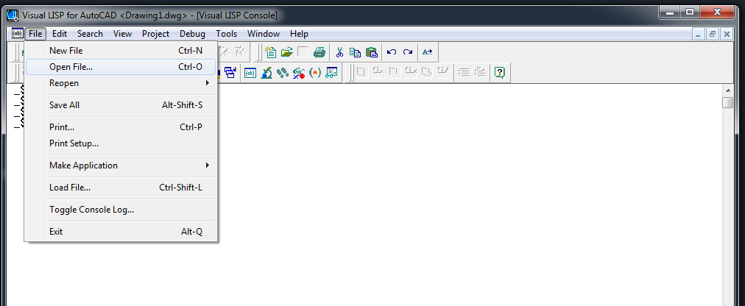

* + 1. Open this file
    2. C:\WS_Blocks\Default\LISP\acadoptions.lsp

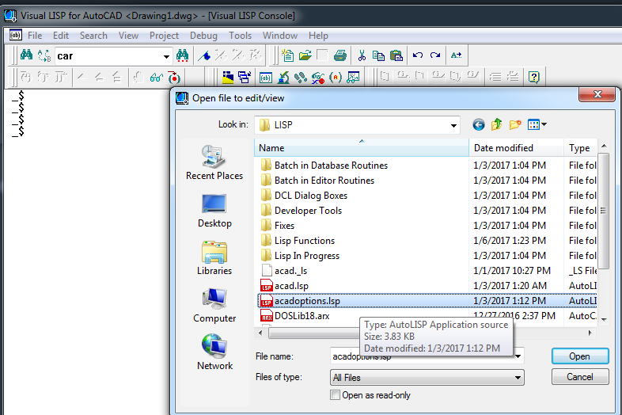

* + 1. Click the load into active window button, highlighted in red

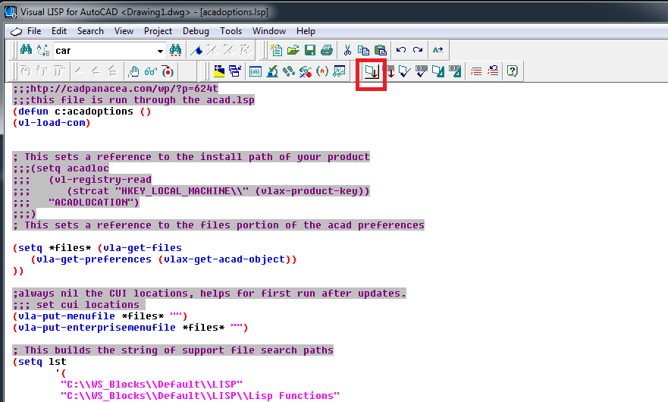

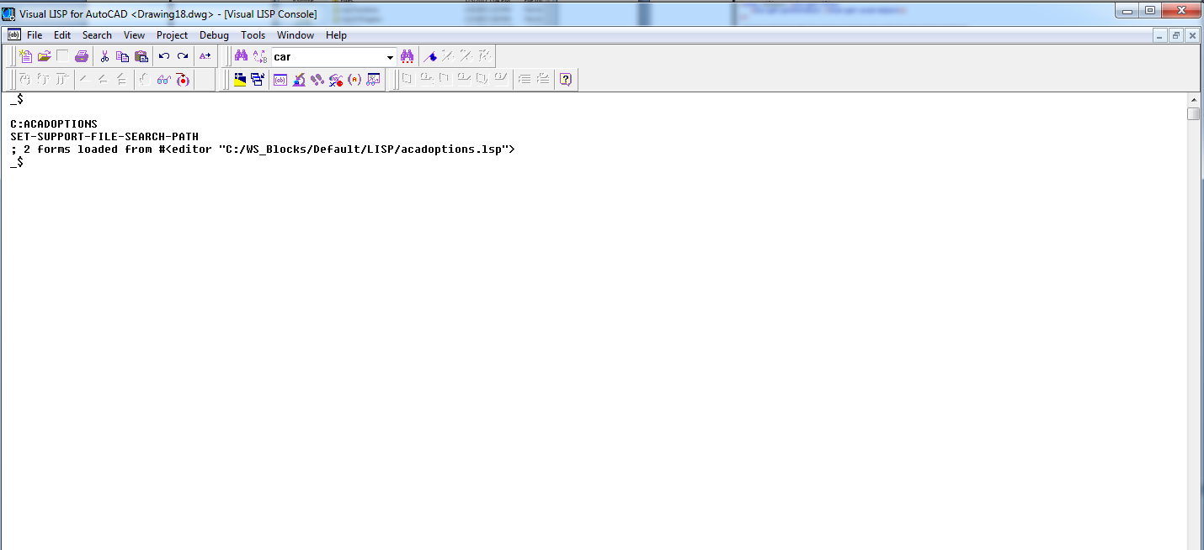

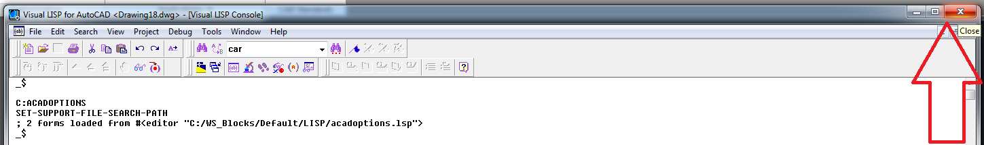

* + 1. Go back to the AutoCAD command line, by clicking close in the top right
    2. Type ACADOPTIONS
    3. Type Enter
    4. Close AutoCAD and re-open
    5. This will load the tool palettes automatically if they are saved in the workspace

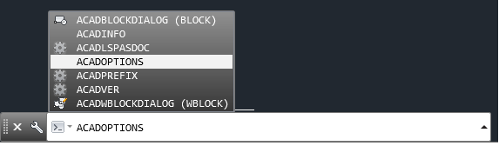

* 1. **Import Palettes**
     1. Re-open AutoCAD
     2. Make sure tool palettes are displayed (on the right hand side)
     3. Use (ctrl + 3) command to toggle the tool palette visibility if it is hidden
     4. Hover over the palette bar to open the fly away window
     5. Right click on the fly away window
     6. Select customize palette

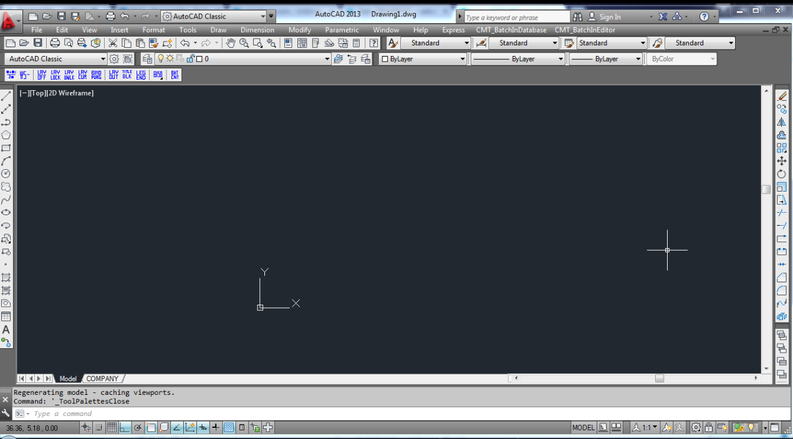

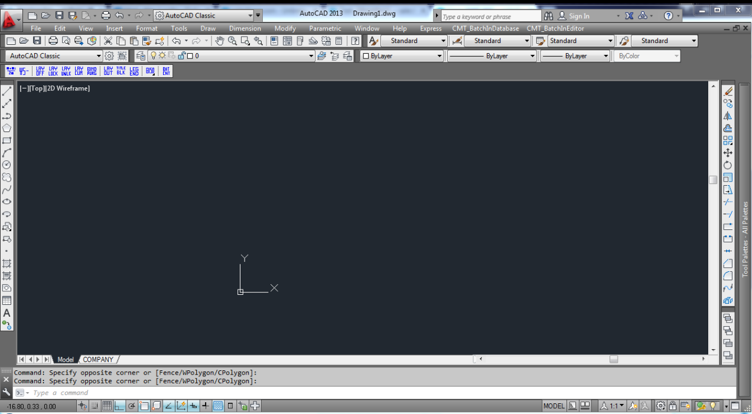

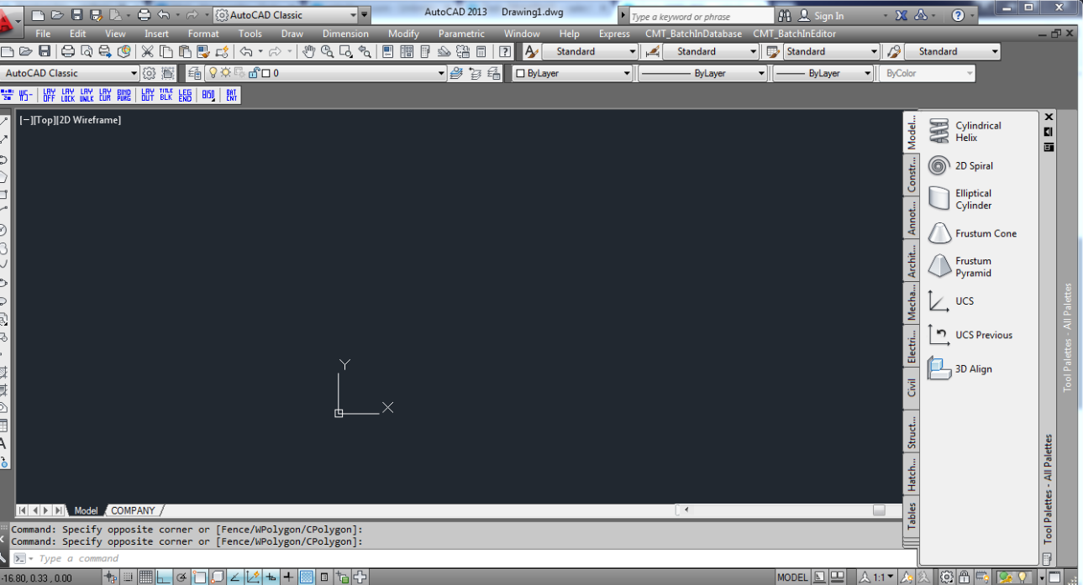

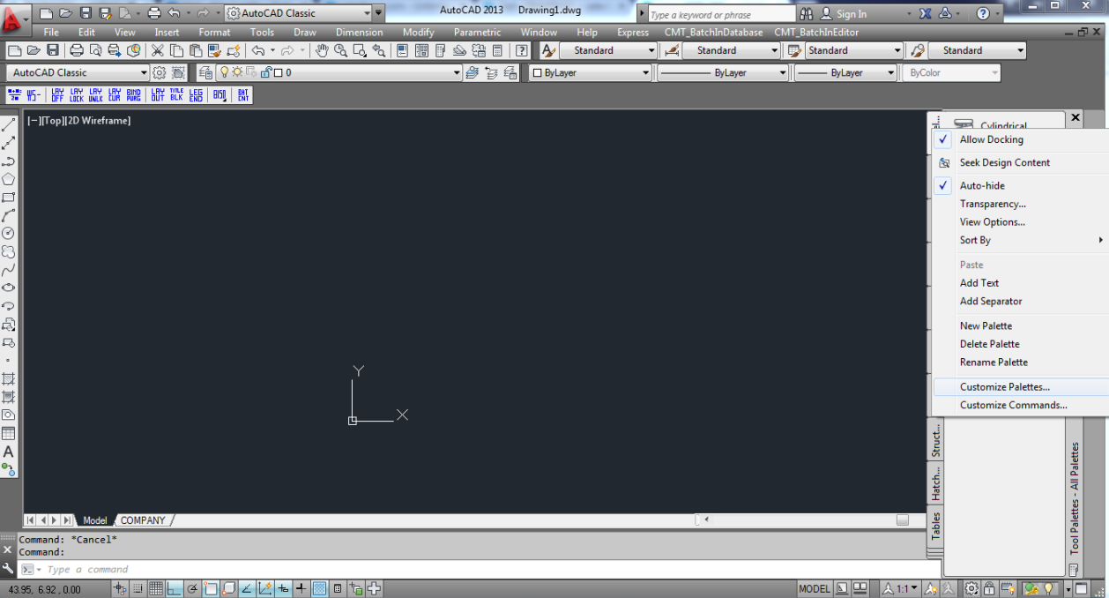

* + 1. On the left hand side there is a dialog box showing all available tool palettes
    2. Delete all the default AutoCAD tool palettes (Modeling, Constraints, ect.)
    3. Leave all the Lighting Controls tool palettes
    4. Full list here -> C:\WS_Blocks\Default\ToolPallete\Palettes

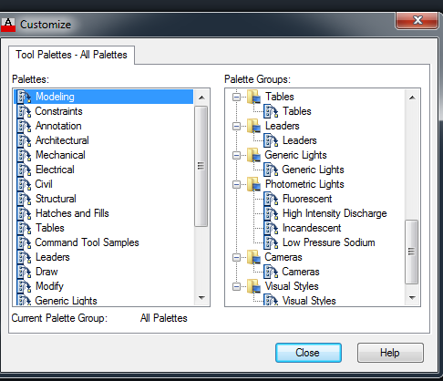

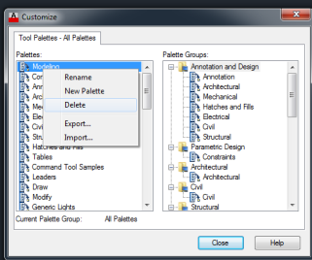

* + 1. On the right hand side there is a dialog box to import tool palettes groups
    2. Right click
    3. Select import
    4. Select both these groups.
    5. Found here:
    6. C:\WS_Blocks\Default\ToolPallete\Palettes
    7. Default Palette Group.xpg
    8. C:\WS_Blocks\Custom\ToolPallete\Palettes
    9. Custom Palette Group.xpg

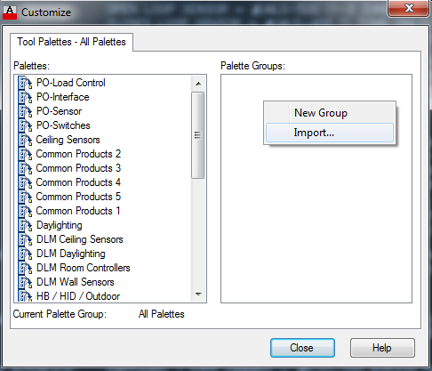

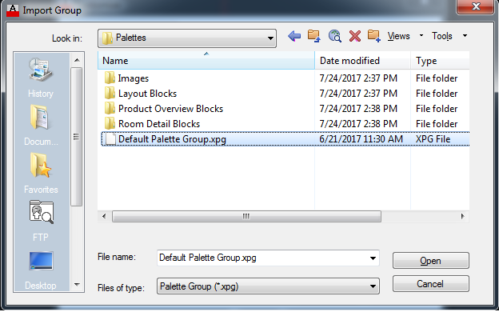

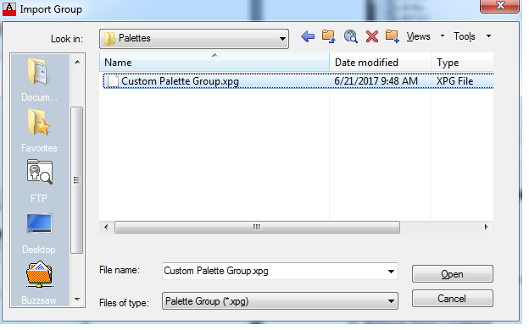

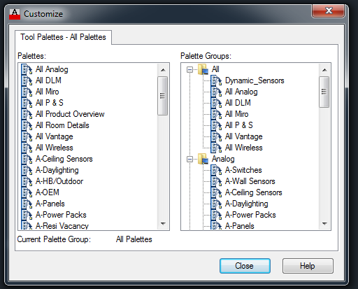

* 1. **Setup Complete**

## Lisp Routines

* 1. Type WS followed by enter into the AutoCAD command line for an overview of custom lisp commands.

## Network Drive Locations

* 1. **H:\Drawings**
     1. CAD Documentation
        1. CAD Operations
        2. CAD Training
        3. Examples
           1. Jobs with step by step instructions for CAD standards **(currently under construction)**
     2. Executables for startup
        1. Server locations for printer setup
        2. .exe for SFDC folder application
        3. .exe for Drive mapping
     3. TW Database
        1. Basic TW details
        2. Lots of wiring schematics in one file
        3. Quicker than the P drive
     4. WS_Blocks
        1. Wattstopper standard folder
        2. Paste to C drive
  2. **P:\Drawings**
     1. Border Templates 2016
        1. Every Wattstopper title block (pre bid, ect)
     2. Main TW Database
        1. The details are categorized by sub folders
        2. This is the main location for all details not included on the H Drive
        3. Each detail is separated into it’s own drawing